Investing a Percentage of Your Income (II) - Corrected Full Answer
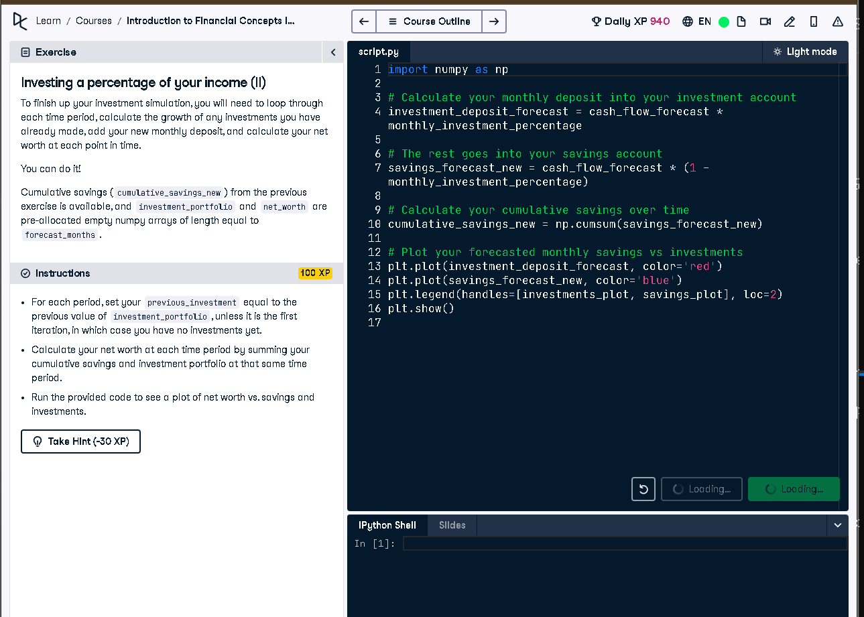

Full Code Answer:
import numpy as np
# Loop through each forecast period
for i in range(forecast_months):
# Find the previous investment deposit amount
if i == 0:
previous_investment = 0
else:
previous_investment = investment_portfolio[i-1]
# Calculate the value of your previous investments, which have grown
previous_investment_growth = previous_investment*(1 + investment_rate_monthly)
# Add your new deposit to your investment portfolio
investment_portfolio[i] = previous_investment_growth + investment_deposit_forecast[i]
# Calculate your net worth at each point in time
net_worth[i] = investment_portfolio[i] + cumulative_savings_new[i]
# Plot your forecasted cumulative savings vs investments and net worth
plot_investments(investment_portfolio, cumulative_savings_new, net_worth)

Question:
How do you compute net worth over time by combining investment growth with savings deposits each forecast period?

20-word Explanation (Question):
Net worth calculation includes cumulative savings plus investment portfolio growth, updated monthly for accurate financial forecasting.

Answer:
Each month, grow previous investments by monthly rate, add new deposits, then sum with cumulative savings for net worth.

20-word Explanation (Answer):
We simulate monthly compounding on investments and add cash deposits, then combine with savings to track net worth.

